**Optimizing Hydrokinetic Turbine Blade Design for Enhanced Efficiency in Variable Flow Conditions**

C. Roderick[1] and B. Reilly[2],

Wentworth Institute of Technology – Mechanical Engineering Department, Boston, Ma, 02115

and

E. Agyekum[3]

Wentworth Institute of Technology – Mechanical Engineering Department, Boston, Ma, 02115

Faculty advisor Professor El-Sadi

The objective of this work (a paragraph): the abstract will be written by the end of the semester, it is a summary of the project including the CFD results and the validation.

# Nomenclature

*A* = amplitude of oscillation

*a* = cylinder diameter

*Cp*= pressure coefficient

*Cx* = force coefficient in the *x* direction

*Cy* = force coefficient in the *y* direction

c = chord

d*t* = time step

*Fx* = *X* component of the resultant pressure force acting on the vehicle

*Fy* = *Y* component of the resultant pressure force acting on the vehicle

*f, g* = generic functions

*h* = height

*i* = time index during navigation

*j* = waypoint index

*K* = trailing-edge (TE) nondimensional angular deflection rate

# Introduction

S

ince the industrial revolution there have been exponential changes in the means of converting natural resources to energy to help make everyday life easier, while also granting new feats of engineering and development to be

accomplished. However, since the invention of the steam engine, greenhouse gas emissions have also been on the

rise. CO2 is the most significant greenhouse gas due to its natural high atmospheric concentration and heat-trapping

capabilities. CO2 accumulation in the atmosphere has risen exponentially. Pre-industrial revolution, CO2 was at a

level of 280 parts per million (ppm), in 2005 CO2 levels were recorded with an increase of over 35% reaching to a

level of over 379ppm. [7] To help combat this, in recent years, new forms of energy generation have been further

adopted and developed. Transitioning to emphasize low-emission energy generation. For example, nuclear energy,

hydroelectric power (HEP), or renewable energy sources, such as wind turbines, and tidal energy. Yet there is one

form of clean energy generation that has been enhanced and modernized over thousands of years. Prometheus may

have stolen fire from the gods, but the Greeks harnessed the power of hydrokinetics from the energy of running

water. The first recorded use of HEP was in the form of waterwheels powering a used to grind wheat into flour.

Hydrokinetics is energy generated from moving water currents in rivers, ocean tides, or any other forms of artificial

water channels. Technology from the water wheel to horizontal axis turbines has been developed to extract and

energy for later use. [5] HEP is the most widely used source of energy generation globally, there has been great

advances in the development and application of HEP. HEP today aims to have a limited effect on the ecosystem

where the system is located. This entails making the systems smaller while increasing or sustaining the same energy

production rate is vital to expanding the usage of these systems for developing clean and renewable energy across

the globe.

HEP has proven its ability to provide usable clean energy across the world. HEP is one of the leading clean energy sources that can reduce CO2 emissions across the world. As of 2023, HEP is the leading source of low-carbon energy producer across the globe, which reflects 16% of the world's demanded electricity [1]. Having this weight on global power production provides great insight into reasoning for further research and development towards a broader range of usable applications for HEP and increased turbine design for usage in wildly differing areas where there are specific environmental factors that affect the hydroelectric turbine energy output. This shows to be prevalent due to the changes in rivers and waterways across the globe on a yearly basis along with climate changing factors such as rainfall and watershed due to seasonal changes, and climate change causing irregular rainfall patterns and extreme geological events is believed to be a major factor in fluctuating of HEP production [2]. This opens reasons for increasing the development of turbines that can effectively make internal changes that will produce a maximum output of power no matter what the environmental factors are during a specific period of time.

The current state of HEP within the United States has been slowly increasing since the late 1800’s. This type of renewable clean energy has drastically increased in energy production over the past few decades. By the end of 2022, the United States conventional HEP fleet consisted of 2,252 HEP plants that cumulatively held a capacity of 80.58 GW, which sums to 28.7% of renewable energy within the United States. This 28.7% correlates to 6.2% of the total energy produced within the United States. There are plans in the making to introduce new HEP facilities that are based on river-stream applications that have not previously been used for energy production [3]. It is known that there are many variables with river-stream systems that change throughout the year. Turbine design is directly correlated with efficiency, having a turbine that can adapt to the changes can be a leading design consideration to increase the production of renewable clean energy within the United States and across the globe.

There are two main types of HEP turbines, reaction turbines and impulse turbines. Reaction turbines generate power from the combined forces of pressure and moving water, with the runner placed directly in the water stream. They can operate in rivers, channels, tidal waters, or ocean currents without requiring large civil works. The most common reaction turbines are propeller (including Kaplan) and Francis turbines. Propeller turbines generally have 3-6 blades and the water contacts all the blades constantly. There are several variations like bulb, Straflo, and tube turbines. Kaplan turbines have adjustable blades and wicket gates for a wider range of operations. Impulse turbines use the velocity of the water to move the runner and discharge at atmospheric pressure. The two main types are Pelton and crossflow turbines. Pelton turbines have free jets discharging water into the runner buckets, while cross-flow turbines have an elongated nozzle directing water through the curved vanes of a cylindrical runner. The driving factors behind choosing a specific turbine depends on variables like the height of standing water (head), the flow rate at the site, as well as turbine efficiency, and overall cost [6].

The focus of this report is based on reaction turbines, having the river flow being the primary source of mechanical energy. This negates the need for potential energy from the pressure head available from structures like dams. Hydrokinetic energy as a resultant of the flow allows for a “zero-head” or “in-stream” turbine. Hydrokinetic turbines are a type of reaction turbine and generate electricity from hydrokinetic energy rather than potential energy from head pressure. Turbine blades are essential components responsible for converting hydrokinetic energy into mechanical rotation. Their design and construction are finely tuned to maximize efficiency and durability in varying water conditions. A major design consideration of reaction turbine assemblies are the turbine blades. Testing turbine blades takes into consideration the angle of attack in conjunction with the orientation and or number of blades used. There is a direct correlation between the flow rate, angle of attack, turbine rpm, and energy generation, such as having a lower blade angle tends to produce an increased rpm which will result in a higher energy generation [8]. These modifications are made to improve upon energy generation or turbine efficacy without making other alterations to the turbine assembly.

By making slight alterations to the turbine blades during testing it becomes possible to determine the optimal blade geometry for the environmental and geographical factors of the turbine’s location. Two major quantifiable factors that are tested are the turbine rpm and energy output. These factors are tested at a standard flow rate while changing one aspect of the turbine blades at a time, the angle of attack, and then the number of blades. Once the optimal blade geometry is determined, the flow rate is adjusted. This process continues to be repeated until a wide variety of flow rates have an optimal turbine blade design. This aids in producing a standard relation between flow rate and blade geometry, resulting in a graph displaying the ideal angle of attack and number of blades for the varying flow rates.

# Solid works model

The apparatus (Figure 4) is made up of two outer fixtures (Figure 1), two passage pipes (Figure 2), a propeller mount (Figure 3) located in the mid-section and the propeller itself (Figure 5). The outer fixtures allow for connection to both the water inlet and outlet of the Gunt HM112 Fluid Mechanics Trainer experiment system via a threaded insertion point. Each passage pipe is then secured to an outer fixture using sealant and an O-ring. The passage pipe has an outer diameter of 80 mm and is with a length of 100 mm. Clear acrylic was used to allow for visual inspection of the flow as well as a view of the propeller. Another set of O-rings and sealant is used to secure both ends to the propeller mount in the middle. The entire structure is then secured using steel rods connected with M10 hex nuts and washers on both ends as seen in (Figure 4 and 4a). The propeller mount is composed of two separate parts, one being the outer cylinder with a 20 mm diameter hole centered on one face and the other being the rotational motion passage. The propeller is then fastened through the mount to a pair of bevel gears arranged at 90 degrees, allowing the rotational motion of the propeller to be taken outside the apparatus and connected to a generator. Connecting the generator in this manner allows for saving time and cost in not having to waterproof the generator itself or spend time creating a waterproof housing that would affect the flow of water, in turn reducing the overall system’s efficiency.

The Kaplan-style propeller with multiple Angle of Attacks (Figure 5a-5c) is designed to allow the angle of attack to be change manually throughout testing. The propeller is attached to a 1/8-inch steel shaft that runs through the propeller mount to the first bevel gear. This allows for the motion of the propeller to be translated to the second gear, hence the shaft of the generator. Thus, allowing for a numerical voltage output of the work done by the propeller at the pre-set attack angle.

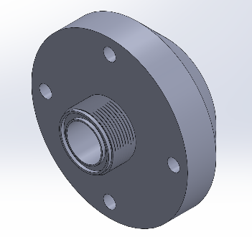

*(Figure 1 – Fluid Table Fixture) (Figure 2 – Passage Pipe)*

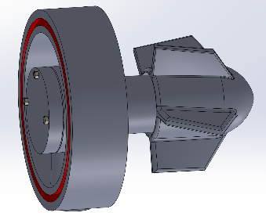 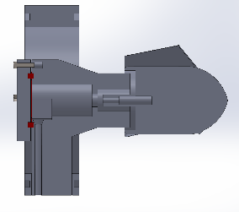

*(Figure 3 – Propeller Mount) (Figure 3a – Propeller Mount Cross-Section)*

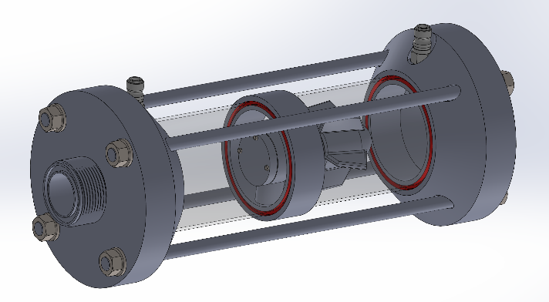

*(Figure 4 – Apparatus Assembly)*

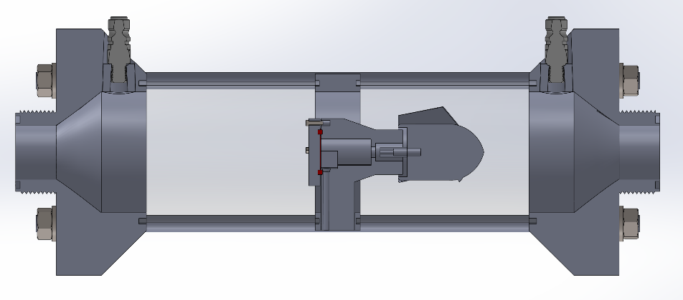

*(Figure 4a – Apparatus Assembly Cross-Section)*

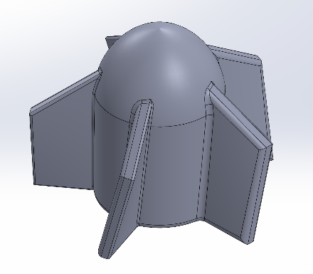

*(Figure 5a – Kaplan-Style Propeller 15° Angle of Attack) (Figure 5b – Kaplan-Style Propeller 45° Angle of Attack)*

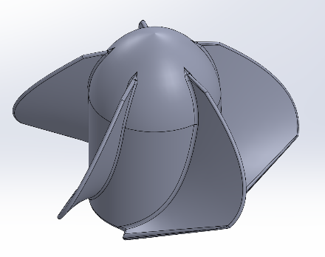

*(Figure 5c – Kaplan-Style Propeller 67.5° Angle of Attack)*

# Building prototype and Testing

* Write a brief paragraph about the manufacturing process and testing
* show sample of calculation
* summarize the results in a table

# CFD_analysis

The geometry of the apparatus is a crucial factor when utilizing computational fluid dynamics (CFD) to analyze a part or assembly. In this instance, the basic geometry being evaluated is a pipe with an internal diameter of 76 mm, an external diameter of 80 mm, and an overall length of 235 mm. When setting up the CFD, the conditions of the system were chosen to exclude the fluid table fixtures (Figure 1), which is important for accurately representing the cross-sectional area under evaluation, measured at 4536.46 mm². Another significant aspect of CFD analysis is the type of fluid used. In this experiment, water at a temperature of 20°C is utilized, with the following relevant properties: density (ρ) = 998.21 kg/m³, dynamic viscosity (μ) = 0.0010016 Pa·s (N·s/m²), and kinematic viscosity (ν) = 1.0035 x 10⁻⁶ m²/s. Additionally, the type of flow is a critical component in CFD analysis. Given the apparatus's design, internal flow conditions are applied, which impacts the equation set used to determine the overall force exerted on the propeller in the direction parallel to the flow.

## Boundary conditions

|  |  |
| --- | --- |
| Table 1 – Boundary Conditions | |
| Inlet Position | 0.000 m |
| Outlet Position | 0.235 m |
| Cross-Section Area | 4.546 m2 |
| Inlet Volume Flow Rate | 2 – 2.7 m3/h |
| Environmental Pressure | 1023.5 mmHG |
| Water Temperature | 26°C |

## Meshing

|  |  |
| --- | --- |
| Table 2 – Meshing Characteristics | |
| Total Number of Cells | 2,019,206 |
| Total Number of Fluid Cells | 2,019,206 |
| Shape of Cells | Square |
| Number of Iterations | 10,000 |

## Analysis

**Case I 15° Angle of Attack**

* Show that your solution is converged, the graph of number of iterations vs. the equations.

* Show the contour of the flow (velocity, pressure) with the legend

Velocity

Pressure

* Write a paragraph to discuss the convergence of your solution and the contour of the flow

Flow converges after approximately 30 iterations. The contours of the flow show high velocity and pressure at the inlet that gradually reduces as especially after the fluid comes into contact with the propeller and after it leaves the body of the propeller.

**Case II 45° Angle of Attack**

**Case III 67.5° Angle of Attack**

## Discussion

Based on the comprehensive CFD analysis, several clear conclusions can be drawn regarding the efficiencies of the propellers tested at multiple angles of attack. The study involved extensive CFD iterations to assess the performance of three different propellers with angles of 15 degrees, 45 degrees, and 67.5 degrees. Each propeller demonstrated significantly different efficiencies when tested at the baseline input flow rate of 3 m³/s.

Efficiency was quantified by measuring the force exerted on the fin face along the x-axis. The results indicated a clear hierarchy in performance. As anticipated, the 67.5-degree propeller generated the highest force, outperforming the 45-degree propeller, which in turn surpassed the 15-degree propeller. This gradation in performance underscores the critical role of the angle of attack in determining propeller efficiency.

The observed outcomes are consistent with theoretical expectations, reinforcing the notion that there is a strong relationship between the input flow rate of water and the angle of attack. Specifically, as the surface area of a fin that is parallel to the flow increases, the total forces acting on the propeller also increase. This increment in force directly correlates with enhanced efficiency and higher voltage output from the hydroelectric generator.

The accompanying graphs provide a visual representation of these findings, clearly illustrating the relationship between flow rate, angle of attack, and voltage output. These graphs confirm that as the angle of attack increases, the efficiency of the propeller improves, leading to greater voltage generation. This analysis not only validates the initial hypotheses but also offers valuable insights into optimizing propeller design for hydroelectric applications.

In conclusion, the CFD analysis has provided robust evidence that varying the angle of attack significantly impacts propeller efficiency. The 67.5-degree propeller emerged as the most efficient, highlighting the importance of optimizing fin surface area in relation to flow direction. These findings contribute to the broader understanding of hydroelectric power generation and pave the way for further advancements in turbine design and optimization.

# V. Validation

Your CFD analysis should be validated by experiments. The CFD results should be compared to experimental results. Discuss the results (one page)

Show pictures of your experiment and create a table to compare the results

# Conclusion

A conclusion section is not required, though it is preferred. Although a conclusion may review the main points of the paper, do not replicate the abstract as the conclusion. A conclusion might elaborate on the importance of the work or suggest applications and extensions. *Note that the conclusion section is the last section of the paper that should be numbered. The appendix (if present), acknowledgment, and references should be listed without numbers.*

# Appendix

An appendix, if needed, should appear before the acknowledgements.

# Acknowledgments

The preferred spelling of the word “acknowledgment” in American English is without the “e” after the “g.” Avoid expressions such as “One of us (S.B.A.) would like to thank…” Instead, write “F. A. Author thanks…” *Sponsor and financial support acknowledgments are also to be listed in the “acknowledgments” section.*

# References

[1] Ahialey, Kabo-Bah, and Gyamfi, “Impacts of LULC and climate changes on hydroelectric power generation and development: A systematic review,” *ScienceDirect*, Vol. 9, Issue 11, Nov. 2023, e21247.

[2] Sharma, Mishra, and Baral, “Climate change impacts on Seti Gandaki River flow from hydroelectric power perspectives, Nepal,” *Springer Nature Journals,* Vol. 10, No. 28, 2024.

[3] Uria Martinez, Rocio, and Johnson, Megan, “U.S. Hydroelectric power Market Report 2023,” *United States*, Jan. 2023.

[4] W.F. Florez-Escobar, F. Chenjne, C.A. Brebbia, and F. Mondragon, “Energy and Sustainability VI,” *Computational Mechanics International,* Vol 6, 2015.

[5] Anyi M., and Kirke B. “Evaluation of small axial flow hydrokinetic turbines for remote communities,” *Energy Sustainable Development*, pp 110-116, 2010.

[6] Waterpower Technologies Office, “Types of Hydroelectric power Turbines”, *U.S. Department of Energy*, 2023.

[7] Mohajan and Hardham, “Greenhouse gas emissions increase global warming,” *International Journal of Economic and Political Integration*, Vol. 1,No. 2, Dec. 2011.

[8] Lillahulhaq, Sandy, Mahardika, Akbar, Saragih, “Experimental study of small hydro turbine propeller performance with a variety of blade angles of attack,” *Sinergi*, Vol. 26, No. 3, Oct. 2022.

1. Insert Job Title, Department Name, Address/Mail Stop, and AIAA Member Grade for first author.
2. Insert Job Title, Department Name, Address/Mail Stop, and AIAA Member Grade for second author.
3. Insert Job Title, Department Name, Address/Mail Stop, and AIAA Member Grade for third author.